Network testing tools

Q1. Use the ping command to test connectivity from your computer to www.youtube.com and note the average response time.
Ans.
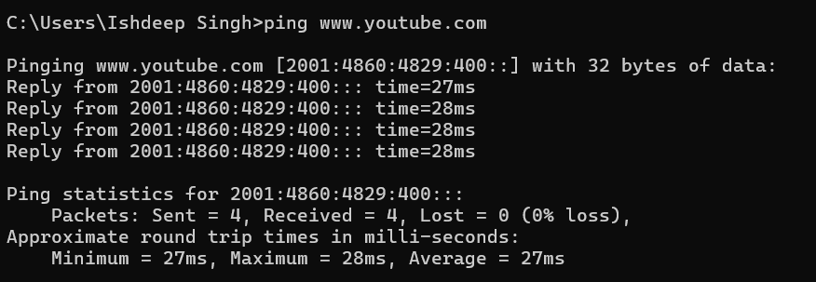
Q2. Run the traceroute (tracert on Windows) command to www.flipkart.com and list all the intermediate hops shown in the output. Hint: Each hop represents a network device your data passes through to reach the destination.
Ans.
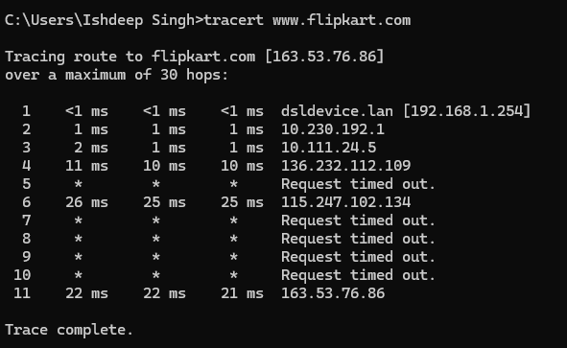
Q3. Use the nslookup tool to find the IP address of www.zomato.com and record the result.
Ans.
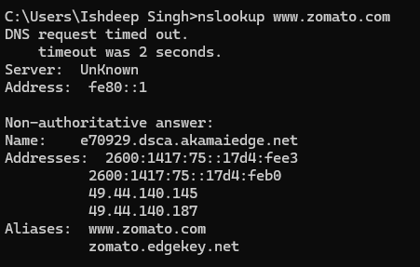
Q4. Test connectivity to another device on your local network (such as your friend's laptop or your phone) using the ping command and describe what happens if the device is offline.
Ans. Before The Device Goes Offline it Successfully gives reply
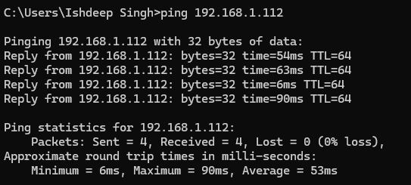
- After The Device Goes Offline it Shows Request Time Out
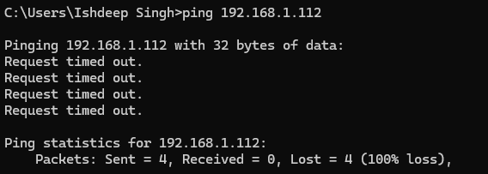
Q5. Create a short report (5-7 lines) summarizing which tool (ping, traceroute, nslookup) is most useful for diagnosing each of these problems: (a) Website not loading, (b) Slow connection, (c) Suspecting DNS issues. Constraint: Give a specific example for each tool based on your own test results above.
Ans. Short Report
- Website not loading: ping is useful to check whether the website/server is reachable; my test showed successful replies from the destination.
- Slow connection: traceroute is most useful because it shows each hop and can identify where delays occur; my test showed the route and response times for each hop.
- Suspecting DNS issues: nslookup is best for checking whether a domain name resolves to an IP address; my test successfully resolved the website’s domain to an IP.
- Ping: helps identify basic connectivity and packet-loss problems.
- Traceroute: helps locate network hops where latency or routing problems may occur.
- Nslookup: helps confirm whether DNS is correctly translating a website name into an IP address.

